Contest Leader Board

Problem Statement
Design the online coding contest leader board. (May be extended for some other online contest also)

Clarify the Problem Statement
This is like the Leet-Code or Code-Chef kind of contest and when ever user submits the solution for the problem we need to show the leader board accordingly.
Example
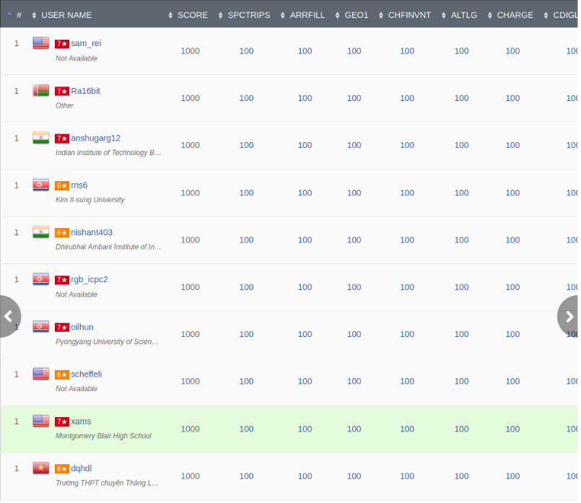

Functional Requirements
User should see Rank-list on the Dashboard (Real time)
Finalize the Contest at the end
Here there is only one actor : Participant

Non-Functional Requirements
After submission user should see the updated rank list on the dashboard
Availability vs Consistency (Will discuss later)
Is there is need of caching ?
Is there is need of DB scaling ? and how to handle this?

Requirement Gathering
How many maximum number of participants will involve in contest?
What is the duration of contest?
How many questions will be asked?
What is the way to determine the leader if there is tie between 2 participants?
Like time taken to solve, or any penalty is being taken

How many participants ?
In the world 50 million people are coders and if I take 80 – 20 % rule then only 20% of them are active coders
50 * 0.2 = 10 million people

But per contest active user might be 100k participants

Duration of the contest is about 3hr

5 Question
Avg submission / problem / participant = 2
Total submission/problem will be 100k * 2 = 200k submission / problem
Total 5 problems
Total submission is = 1000k submission

Avg submission / second is = 1000K / 3 * 3600 seconds = 1000k / 10^4 = 100 submissions / seconds
Peak load = 2 * avg load = 200 submissions / seconds

How to Compute the Rank-List ?
High level Schema’s involved :
- Participants : participant_id, name, email, royalty_score
- Contest : contest_id, contest_name, contest_duration
- Problems : problem_id, problem_name, problem_difficutly, problem_description, time_complextiy, space_complexity
- Tests : test_id, test_name, test_case_url, test_level_difficulty
- Submission : user_id, contest_id, problem_id, problem_name problem_name, score, time_taken,
- Contest_user : joninng 2 tables
- Similarly other tables

Mainly for computing the rank list we need to join the tables submissions, contest and problems and users mostly
And roughly each record may have 200 bytes of memory
Hence 1000k * 200 bytes = 200 MB for each contest and compute the rank list

How frequently user see the rank-list ?
If I assume every 10 min each user visit the rank-list then
20 views / user / 3hr
So total views are = 100k * 20 = 2000k views / 3hr = 2000k / 10000 second = 200 views / seconds
Each time if have to fetch 200 MB data to compute the rank list then it is load to the server hence there is need of cache
And we can go for availability instead of consistency as it is okay to lag some time to update the rank-list but we need to show the data and serv 200 views / seconds
For 100 + participants we can go for pagination and for each page we can show 10 users data
Hence for each page it will be 2k data we need to fetch and 200 views / seconds we need to serv hence we can go for Global cache and at max we need to sore only 200 mb of data hence we can have Global Single Cache system.

Is immediate consistency required?
No, It is okay to show the stale data for some of time

What is the cache invalidation strategy ?
TTL : we can have but if cache miss happens then computation is again costly. We can use this only if db fetch query is not complex
Write Around : We can have asynchronous job that will run for every 10 min and update the cache
But for initial 10 min we can have warm up data with all the participant as rank 1
Cache will look like
Contest:1:page:1 = [{participant’s data }..10 enties]

Eviction Policy : No required here as per contest only max data is 200 MB
Overall system Architecture looks like
